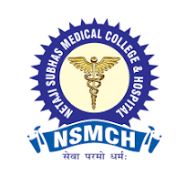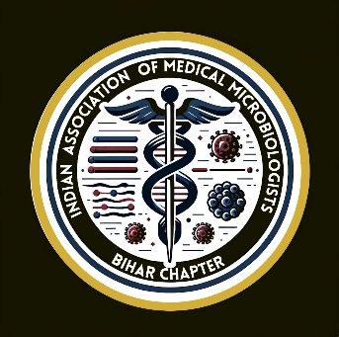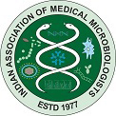

**Netaji Subhas Medical College & Hospital**

**Amhara, Bihta, Patna**

**1st Annual State Conference**

**IAMM Bihar Chapter-2024**

**20-21st Septmber 2024**

[**brmicrocon@nsmch.in**](mailto:brmicrocon@nsmch.in)

**Theme**

**HAI- Changing landscape and Newer Challenges**

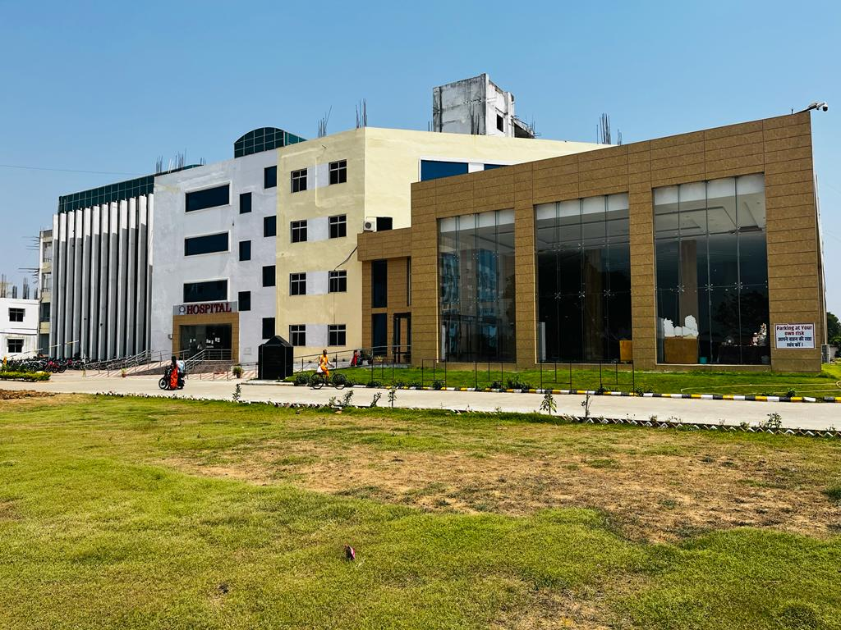

Organized by:

**Department of Microbiology**

**NSMCH, Bihta**

**ABOUT NSMCH, BIHTA**

Netaji Subhas Medical College & Hospital is established by Sitwanto Devi Mahila Kalyan Sansthan at Amhara, Bihta, Patna. The Institute is the brainchild of our visionary Chairman, Shri M.M Singh. Chairman’s idea behind establishment of Netaji Subhas Medical College & Hospital is to provide best in class Medical Education to the students and nurture world class Doctors for the service to the Nation. The medical college is Permitted by Medical Council of India, New Delhi and is Affiliated to Aryabhatta Knowledge University, Patna and BUHS, Patna for its MBBS Course with an Intake of 100 Seats in Session 2020-2021.

The medical college is equipped with state of the art infrastructure for teaching and learning. The Medical College has well established laboratories to support the teaching and hands on learning of the students.

Since inception vision of the institute has been to provide world class medical facilities to the patients for clinical and diagnostic support. The institute has well established and strong Pre Clinical, Para Clinical and Clinical departments with qualified doctors, trained nursing & paramedical staff.

The Medical College will serve as a rostrum for the students to nurture their talent and engrave their ideas with their creative best.

**WELCOME MESSAGE**

Dear members and delegates,

We feel extremely glad to welcome everyone to this much awaited conference, With great honor and immense pleasure, the organizing committee of Department of Microbiology, NSMCH, Bihta, Patna invites you to the 1st Annual state conference of IAMM Bihar Chapter to be held on 20th and 21st September 2024. During these two days you will be showered with scientific information enhancing and updating knowledge on Hospital Acquire Infection. We hereby request your valuable presence for this conference to make this event a grand success.

With warm regards,

Organizing secretary

Dr. Mukesh Kumar

8126221590

Hod of Microbiology

NSMCH, Bihta, Patna

**The Organizers**

**Chief Patrons** :- 1. **Shri M.M Singh (**  Chairman )

2. **Shri Krishna Murari (** Managing Director **)**

**Patrons**: - 1. **Dr. Ashok Sharan (** PRINCIPAL )

2. **Dr. Arvind Prasad (** JOINT DIRECTOR)

3. **Dr. Ramji Prasad (** JOINT DIRECTOR)

**Organizing Committee**

**Organizing Secretary** :- **Dr. Mukesh Kumar**

**Joint organizing secretary** :- **Dr. Anupama Singh**

**Treasurer** :- **Dr. Archana**

**Convener Scientific committee:- Dr. Anubhuti**

**Convener Souvenir committee :- Dr. Shafaquat**

**Convener registration committee :- Dr. Mridushri**

**Office Bearers Of Bihar Chapter Of Indian Association Of Medical Microbiologists 2024**

|  |  |  |
| --- | --- | --- |
|  |  |  |
| **1** | **President-** | Dr (Prof.) Namrata Kumari IGIMS,Patna |
| **2** | **Vice president** | 1. Dr (Prof.) Bhaskar Thakuria, AIIMS Patna 2. Dr (Prof.) Pratulya Nandan, PMCH, Patna |
| **3** | **Secretary** | 1. Dr Priyanka Narain PMCH,Patna |
| **4** | **Joint Secretary** | 1. Dr (Prof.) Ajay Kumar GMCH, Bettiah 2. Dr (Prof.) Arvind Kumar BIMS, Pawapuri 3. Dr Ahsan Hamidi DMCH, Darbhanga 4. Dr Ashwini Kumar NMCH, Sasaram |
| **5** | **Treasurer** | 1. Dr Rashmi Soni Assistant Prof. PMCH, Patna |

**ADVISORY COMMITTEE**

1. **Dr. Harihar Dikshit**
2. **Dr. Ajit Gupta**
3. **Dr. K.K.Lohani**
4. **Dr. C. N. Singh**
5. **Dr. Arjun Kumar Singh**
6. **Dr. Raushan Bhatt**
7. **Dr. A.K. Sahay**
8. **Dr. MD. Shadab**
9. **Dr. Sohan prasad**
10. **Dr. Shivendra prasad Sinha**
11. **Dr. Jiram singh**

**About Bihta and Surroundings**

Bihta is vibrant township located 30 km west of Patna, the capital of Bihar. It is well connected by rail, road and air. It is part of greater Patna being developed. Bihta has been a seat of learning and spirituality since antiquity, Bihta has a famous old temple of Van Devi at Kanchapur, Prachin Jain Temple at Rustom Ganj and a Shiv Temple, Baba Biteshwar Nath in Gultera Bazar. Maner Sharif located 4km from Bihta, has tomb of Sufi Saints Makhdoom Yahya Maneri and Makhdoom Shah Daulat. Of late, Bihta has become an academic hub, with Institution like IIT, Patna, NIELIT (National Ins. of Electronics and Information Tech.) NSIT, NSMCH, ESIC Medical College already functioning here and NIT, Patna soon to be transferred here. Patna International Airport is also proposed to be transferred here.

So, Bihta is an old city with new charm

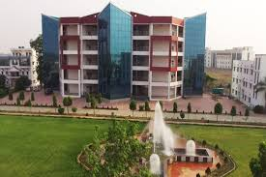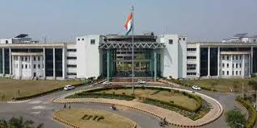

**IIT, Patna NSIT**

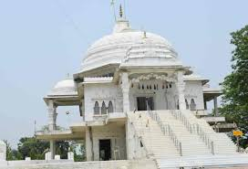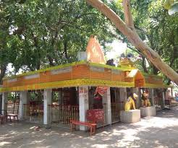

**Maa Vandevi Mandir, Bihta Ancient Jain Temple**

**CONFERENCE REGISTRATION FEE DETAIL**

|  |  |  |  |
| --- | --- | --- | --- |
| **Category** | **EARLY BIRD (upto 30th june )** | **REGISTRATION**  **1ST SLOT UP TO 31ST AUG 24** | **REGISTRATION**  **2ND SLOT AND SPOT 1ST SEPT ONWARDS** |
| **Faculty**  **(IAMM member)** | Rs. 5000 | Rs. 6000 | Rs. 7000 |
| **Faculty**  **(NON IAMM member)** | Rs. 6000 | Rs. 7000 | Rs. 8000 |
| **PG** | Rs. 4000 | Rs. 4500 | Rs. 5000 |
| **Accompanying Person** | Rs. 2000 | Rs. 2500 | Rs. 2700 |

CONTACT PERSON:- Dr. Archana

MOBILE NO :- 8863077454

Email:- [**brmicrocon@nsmch.in**](mailto:brmicrocon@nsmch.in)

**Link to google form:-**

[**https://docs.google.com/forms/d/e/1FAIpQLSeDPZGHlq7ODZb5SwZR_h5K4oKttTqaoJQHBEg1zVVWRW4m0A/viewform?usp=sf_link**](https://docs.google.com/forms/d/e/1FAIpQLSeDPZGHlq7ODZb5SwZR_h5K4oKttTqaoJQHBEg1zVVWRW4m0A/viewform?usp=sf_link)



ACCOUNT NO :- 20011132000686

Account Holder Name: Sitwanto Devi Mahila Kalyan Sansthan

BANK NAME :- PUNJAB NATIONAL BANK

BRANCH :- BIHTA DISTT- PATNA BIHAR 801103

IFSC CODE :- PUNB0200110

**MESSAGE**

Healthcare-associated infections (HAIs) are the most common complication associated with hospital care and continues a significant concern for health care professionals. Centers for Disease Control and Prevention (CDC) reports that one in every 31 hospital patients acquires at least one HAI each day. The potential for HAIs lead to increased morbidity and mortality, costing billions for healthcare organizations further emphasizes the need for HAI prevention measures.

It is imperative for healthcare professionals to direct their focus towards identifying and capitalizing on opportunities for improving performance and outcomes across various departments and specialties related to HAIs and the prevention of infections.

To address this pressing issue, the Department of Microbiology, NSMCH, Bihta is hosting the IAMM Bihar state chapter, First Annual Conference 2024 with the theme “HAI: Changing Landscape and Newer Challenges”. The conference, scheduled for 20th -21st September 2024, will cover topics related to HAIs, with focus on bloodstream infections, urinary tract infections, surgical site infections, and pneumonia associated with health care offering attendees the latest knowledge and updated recommendations for timely infection prevention and treatment. The aim of this two day event is to establish the importance of HAI mitigation with infection prevention and control practices and enhance the overall clinical outcomes for patients affected by HAIs.

Together, as infection control professionals, epidemiologists, microbiologists, physicians, nurses, laboratory scientists, and other medical professionals we need to come forward to understand and mitigate HAIs.

We expect numerous scientific papers, abstracts, and lectures to be presented during the scientific sessions, panel discussion, oral and poster sessions during the two days of the conference which would document remarkable scientific advances and achievements in preventing and controlling infections associated with health care.

The esteemed speakers would also provide an insight into the emerging challenges brought by the changes in the epidemiology and microbiology of pathogens, the growing numbers of patients with increased susceptibility to infection, the rapidly increasing complexity of medical care itself, and the dramatic developments in the organization, structure, and financing of health care. They would also address the topics on device-associated infections, and surveillance: the vital areas of research and investigation.

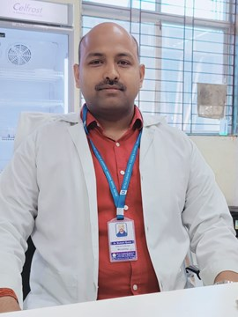 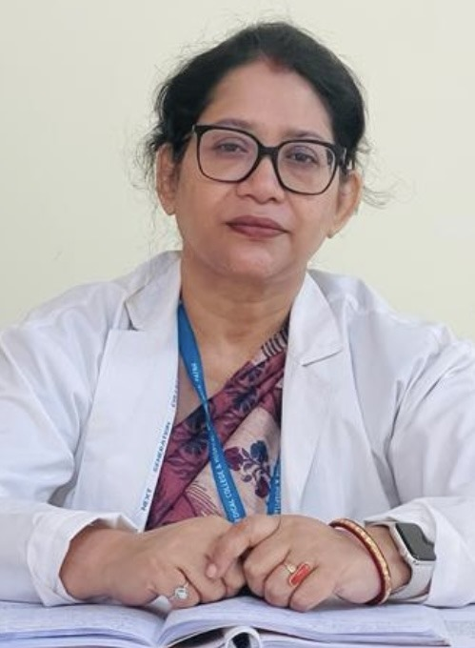

Organizing secretory Joint organizing secretory

Dr. Mukesh Kumar Dr. Anupama singh